F-751 Kiwi Quality Meter
MANUAL

Revised 02/26/2020
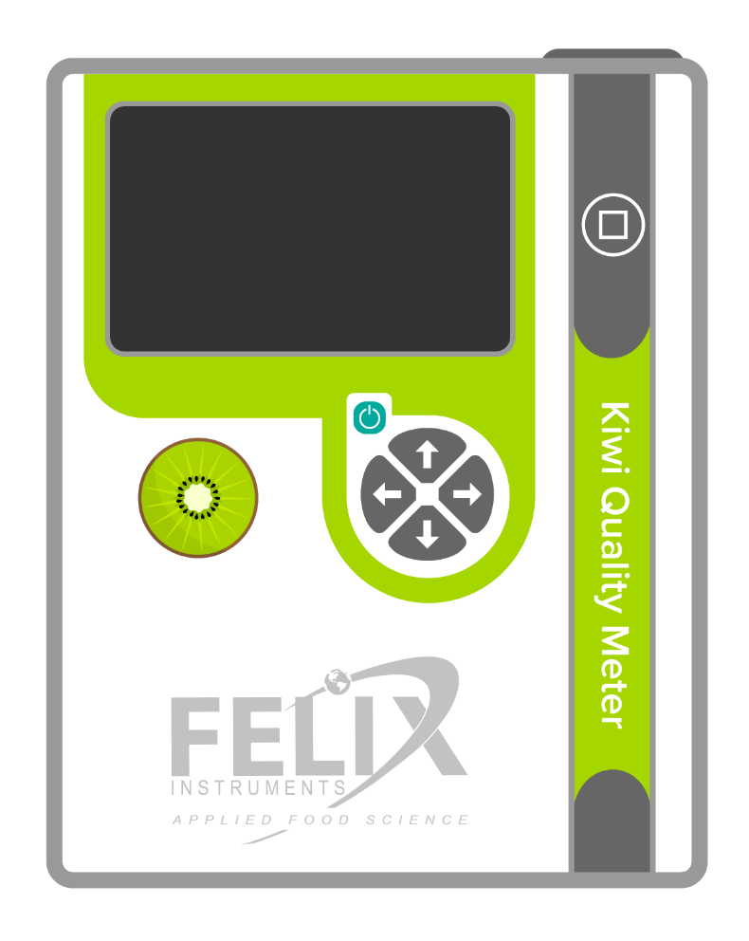
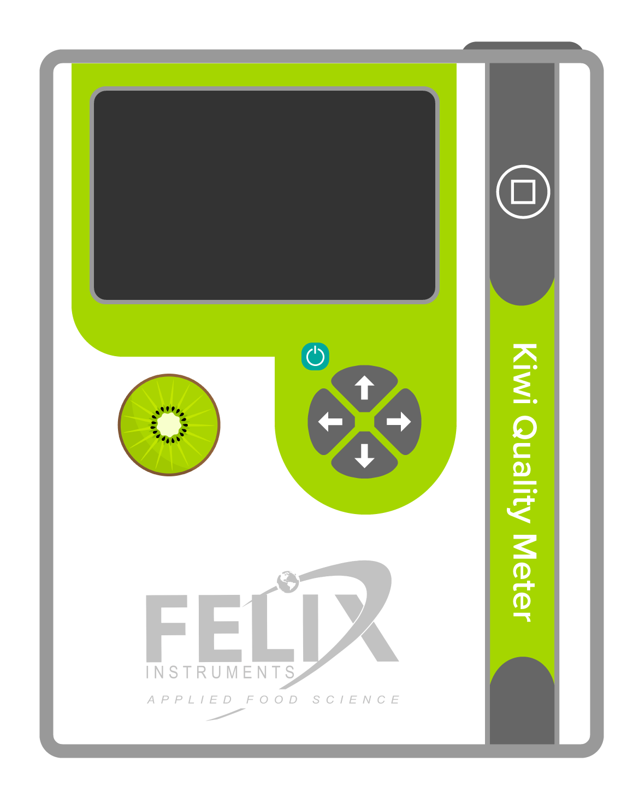
\Plot01\Plant001\Fruit003 14.2% DM
Brix: 15°
01/03/2019 11:34:12 GPS Lock
DECLARATION OF CONFORMITY
Manufacturer:
CID Bio Science, Inc.
Felix Instruments – Applied Food Science
1554 NE 3rd Ave
Camas, WA 98607
Declares that the CE-marked Product:

Product Model(s):
Model F-75x
FCC Compliance Statement:
This device complies with part 15 of the FCC Rules. Operation is subject to the following two conditions: (1) This device may not cause harmful interference, and (2) this device must accept any interference received, including interference that may cause undesired operation.

Complies With:
89/336/EEC Electromagnetic Compatibility Directive
73/23/EEC Low Voltage Directive

Compliance Standards:
EN 55027 RF Emissions Information Technology Equipment
EN 50082-1 EMC Immunity Standard
EN 60950 Safety of Information Technology Equipment
Including Electrical Business Equipment

December 31, 2018

Leonard Felix
President

Contents
Overview 1
Unpacking & Getting Ready for Use 2
Loading the Battery 2
Protecting Your Device 3
Turning the Instrument On 4
Instrument Interface 5
Measuring Kiwis 7
Organizing Measurements 9
Overview of Lots Used to Group Records 9
Organizing an Existing Measurement 10
Organizing New Measurements 16
Updating Lots from Your PC 18
Assessing Your Results 19
Overview of FruitMaps.com 19
Connecting to a Wireless Network 20
Uploading Records to FruitMaps 22
Downloading Measurements to Your PC 24
Downloading Measurements Using Wi-Fi 26
Troubleshooting 27
Technical Support 29
F-751 Production Test Check Sheet 30

Overview

Felix Instruments’ F-751 Kiwi Quality Meter is a fast, portable tool for non-destructively measuring kiwi fruit quality. Combined with FruitMaps.com, the F-751 can rapidly take and assess large numbers of scans, giving grove-wide estimations and insights.
The F-751 primarily measures dry matter. Dry matter is the part of a kiwi which would remain if all its water content was removed. We recommend measuring multiple fruit and then averaging dry matter measurements for a more accurate assessment.

This instrument can operate in 4 languages:
- English
- Spanish
- Portuguese
- Chinese
To change the language on your instrument, follow these steps:
- Use the left/right arrow buttons until you have reached the Main Menu.
- Use the up/down arrow buttons to navigate to Setup Instrument and press the right arrow.
- On the next screen use the up/down arrow buttons to navigate to Language and press the right arrow.
- On the next screen use the up/down arrow buttons to navigate to the language you would like to use. Press the right arrow to choose that language.
This full user manual can also be downloaded in 20+ languages on our website under this product’s page.

Este instrumento puede operar en 4 idiomas:
- Inglés
- Español
- Portugués
- Chino
Para cambiar el idioma de su instrumento, siga los siguientes pasos:
- Use las flechas (botones) Izquierda/Derecha hasta llegar al Menú principal.
- Use las flechas Izquierda/Derecha para navegar hasta Configuración del equipo y presione la flecha derecha.
- En la siguiente pantalla, use las flechas Arriba/Abajo para navegar hasta Lenguaje y presione la flecha derecha.
- En la siguiente pantalla, use las flechas Arriba/Abajo para navegar al idioma que le gustaría usar. Presione la flecha derecha para elegir ese idioma.
Este manual de usuario completo también se puede descargar en más de 20 idiomas en nuestro sitio web en la página de este producto.

Este equipamento pode operar em 4 idiomas:
- Inglês
- Espanhol
- Português
- Chinês
Para alterar o idioma em seu equipamento, siga os seguintes passos:
- Utilize as teclas para esquerda/direita até chegar no Menu principal.
- Utilize as teclas para cima/baixo para navegar até Instrumento de configuração e pressione a Tecla para a direita.
- Na próxima tela use as teclas para cima/baixo para navegar até Language e pressione a Tecla para a direita.
- Na próxima tela utilize as teclas para cima/baixo para escolher o idioma. Pressione a Tecla para a direita para salvar o idioma escolhido.
Este manual completo também pode ser baixado em mais de 20 idiomas em nosso website, na página deste produto.

仪器提供4种语言支持
- 英语
- 西班牙语
- 葡萄牙语
- 中文
如需切换仪器系统语言，请按照以下步骤操作：
- 用左键/右键切换到仪器操作系统主页面
- 用向上键/向下键选择安装仪器选项，按下右键确认
- 在新页面中，用向上键/向下键选择Language选项，按下右键确认
- 在新页面中，用向上键/向下键选择您需要的语言，按下右键确认选择，如需选择中文，请选择中文.
完整版使用手册已翻译成超过20种语言，可以在我司官网的产品页面中下载

Unpacking & Getting Ready for Use

If you have just received your F-751, the instrument will arrive in a carrying case that includes:
- The F-751 Produce Quality Meter
- SD card
- 2 sets of removeable rechargeable standard-sized batteries (4). Additional button-top 19670, or protected 18650, batteries can be purchased from a preferred battery vendor.
- Battery charger (3)
- Hand strap

Loading the Battery
The F-751 uses 18650 Li-ion 3.7V 3100mAh rechargeable batteries. The batteries must be removed from the F-751 to be charged. To remove the batteries, twist the battery compartment cap, located on the bottom of the device under the rubber bumper. The cap can be twisted with fingers or a screwdriver to tighten or loosen. Use caution when removing batteries, as the cap is spring loaded. Both batteries should be inserted into the unit positive (+) side first (towards lens side).
Warning: Do not drop batteries, this may cause them to crack and rupture.

Protecting Your Device

Ensure that the rubber bumpers on the top and bottom of the F-751 are always installed when using the instrument, as they protect it from water damage.
The hand strap should be tightened so that the device has a snug and secure fit around the hand.
If the lens becomes dirty, it can be cleaned with a soft cloth. The lens is made of extremely durable Gorilla Glass and should not become scratched with normal use.

Turning the Instrument On

1. Press the Power On/Off Button, the instrument will turn on.

This process takes a few moments and the display will display Ready when the instrument is prepared to measure kiwis.

Instrument Interface

1. Power On/Off Button
2
1
3
2. Measure Button
3. Navigation Buttons (referred to as Up\Down\Left\Right)

Instrument Interface (Continued…)

Navigating Menus

The instrument’s interface is composed primarily of menus that are operated using the navigation buttons.
Up/Down navigates between menu item.
Left navigates back to the previous menu.
Right navigates into the selected menu item.

Entering Text/Numbers
When prompted text/numbers can be entered using the device using the navigation buttons.
Up/Down navigates between letters/numbers for the current cursor position.
Left navigates the cursor in text that has already been entered. Navigating past the beginning of the text aborts and returns to the previous menu.
Right navigates the cursor in text that has already been entered. Navigating past the end of the text saves your entry and continues.

Measuring Kiwis

1. Position a kiwi over the lens of the instrument…
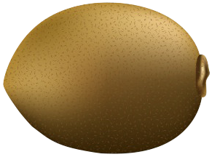
Ready

Measuring Kiwis (Continued…)

2. Press the Measure Button to record a new measurement.
\Plot01\Plant001\Fruit003 14.2% DM
Brix: 15°
01/03/2019 11:34:12 GPS Lock
This process takes a few moments and the display will display Measuring while reading the fruit, then Processing while calculating the results. When completed, your measurement results will be displayed.

Organizing Measurements

Overview of Lots Used to Group Records

Measurements can be grouped using “Lots”. While browsing measurements, each lot displays the number of records along with the average and standard deviation of the Dry Matter values.
\Plot01
Plant001
Records Avg DM % SD σ
0.7
6
22.3
Lot

Organizing an Existing Measurement

While recording a measurement, or while browsing measurements, the Lot is displayed in the upper-left corner of the display. In the example below, the lot is \Plot01\Plant001\Fruit001.
\Plot01\Plant001\Fruit001 14.2% DM
Brix: 15°
01/03/2019 11:34:12 GPS Lock

Organizing an Existing Measurement (Continued…)

After recording a measurement, the Lot this record is assigned to can be changed. To do this, while viewing the record, press the Right button.
\Plot01\
Plant001
Records Avg DM % SD σ
6
22.3
0.7
Lot

Organizing an Existing Measurement (Continued…)

After pressing the Right button, the following menu will be displayed. Use the Up\Down buttons to select the desired action, then press the Right button.
Select Recently Used Lots
Select Lots from List
Enter Lot Manually
Delete Measurement

Organizing an Existing Measurement (Continued…)

If you selected Enter Lot Manually, the instrument will prompt you to enter a new lot. Follow the on-screen directions to enter the text for the lot.
Separating text with a \ (backslash) allows you to have sub-lots within lots.
Separate lots using backslashes, e.g.
Farm1\Plot05\Row03\Plant003
\NewLot
Scroll up and down to select characters.
Scroll right past the value entered to continue.
Scroll left past the value entered to abort.

Organizing an Existing Measurement (Continued…)

If you selected Select Lot from Recently Used, the instrument will display a list of the most recently used lots. Navigate these lots using the Up\Down buttons, then press the Right button to select the desired lot. Alternately, press Left button to return to the previous menu.
\Plot01\Plant001\Fruit001
\Plot01\Plant001\Fruit002
\Plot01\Plant001\Fruit003
\Plot01\Plant002\Fruit001
\Plot02\Plant001\Fruit001

Organizing an Existing Measurement (Continued…)

If you selected Select Lot from List, the instrument will display a list of the lots pre-loaded on the instrument (see page 21 for instructions on updating this list). Navigate these lots using the Up\Down buttons, then press the Right button to select the desired lot. Alternately, press Left button to return to the previous menu.
\Plot01\Plant001\Fruit001
\Room01\Pallet001\Fruit001
\Group01\Tray001
\Fruit001
\Plant001

Organizing New Measurements

1. Press the Left button until you have returned to the main menu.
2. Then use the Up\Down buttons to navigate to Default Lot for New Measurements and press the Right button to select that action.
Browse Measurements
Upload to FruitMaps.com
Default Lot for New Measurements
Setup Instrument

Organizing New Measurements (Continued…)

The menu displayed is identical to the menu displayed for organizing existing measurements (pages 13-19). The difference is that the lot chosen here (from a list or by entering it manually) will be used for all new measurements.
Select Recently Used Lots
Select Lots from List
Enter Lot Manually

Updating Lots from Your PC

1. Turn off the device.
2. Remove the SD Card from the device.
3. Insert the SD Card into your PC.
4. Launch the Notepad app.
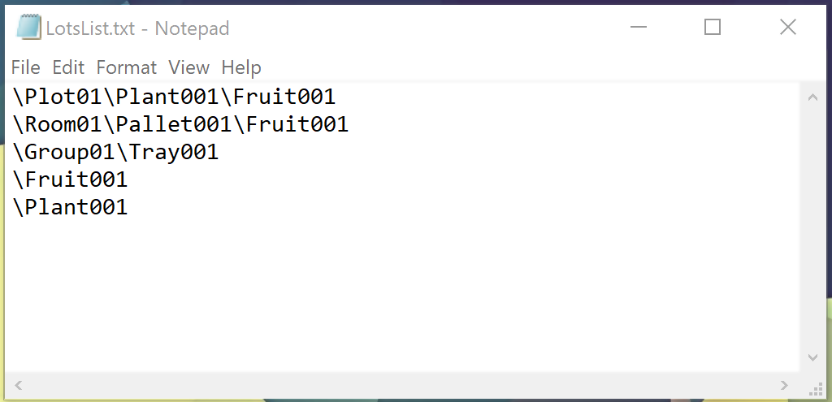
5. Open the file LotsList.txt under the root of the SD Card.

6. Each line entered here will display on the device as a lot.

Assessing Your Results

Users have 3 methods to view and assess measurements:
- Online with FruitMaps.com
- Offline on your PC using the SD Card
- Using on the instrument

Overview of FruitMaps.com

FruitMaps.com, produced in-house by Felix Instruments, is a proprietary application that enables kiwi growers to better visualize their crop data and convert their gathered measurements into actionable harvest insights.
The following pages will guide you first, through connecting the F-751 to a wireless network, then uploading your data to FruitMaps.

Connecting to a Wireless Network

1. Press the Left button until you have returned to the main menu.
Browse Measurements
Upload to FruitMaps.com
Default Lot for New Measurements
Setup Instrument

2. Then use the Up\Down buttons to navigate to Setup Instrument.

Connecting to a Wireless Network (Continued…)

3. Use the Up\Down buttons to navigate to Wireless Network, then press the Right button to select that menu item.
GPS Receiver
Wireless Network
Date and Time
Keypad Sounds
Notification Sounds
Backlight Intensity
Language
Factory Setup

4. Use the Up\Down buttons to navigate to Networks, then press the Right button to select that menu item. Select your network and enter the passcode as directed on-screen.

Uploading Records to FruitMaps

1. Before uploading measurements login to FruitMaps.com and register this device using the serial number. The instrument’s serial number can be found on the Ready screen.
Ready
S/N 75X-002-18016 v1.2.0 build 13000
2. Connect to your wireless network (see page 21).

Uploading Records to Fruitmaps (Continued…)
Browse Measurements
Upload to FruitMaps.com
Default Lot for New Measurements
Setup Instrument

3. Press the Left button until you have returned to the main menu.
Browse Measurements
Upload to FruitMaps.com
Default Lot for New Measurements
Setup Instrument

4. Use the Up\Down buttons to navigate to Upload to FruitMaps.com, then press the Right button to select that menu item.

Downloading Measurements to Your PC

1. Turn off the device.
2. Remove the SD Card from the device.
3. Insert the SD Card into your PC.
4. If you have never used Data Viewer…
4.A. Browse to the Software folder on the SD Card.
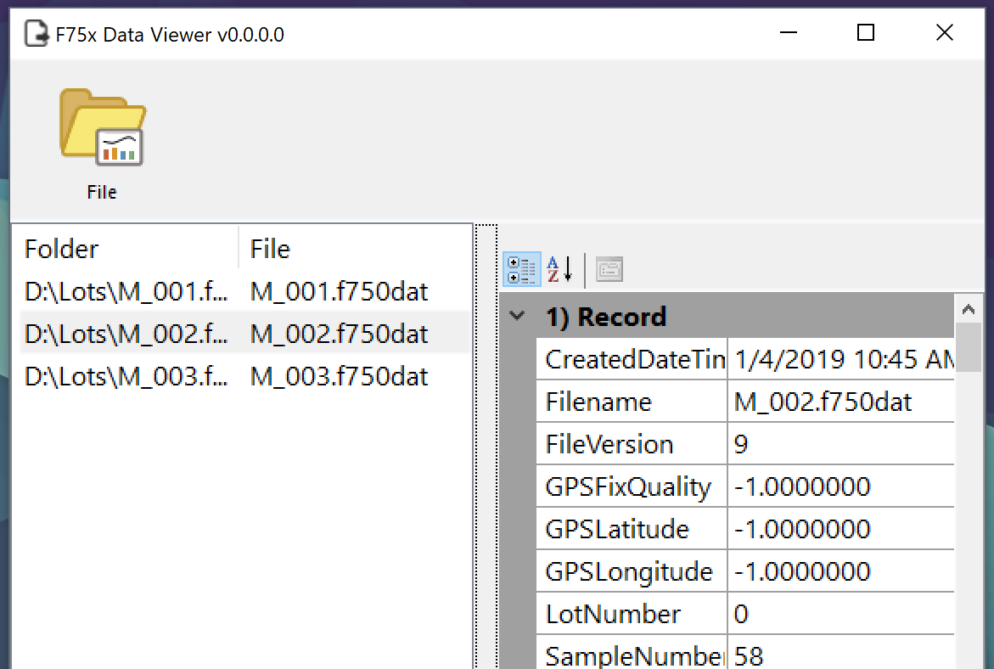
4.B. Run Setup.exe and follow the prompts to install Data Viewer.
5. Launch Data Viewer (from the Window’s Start Menu).
6. Click the File icon or press Alt+F.

7. Browse to the Lots folder on the SD Card and select the data files to view.
8. Click the File icon or press Alt+F.
9. Select Export…
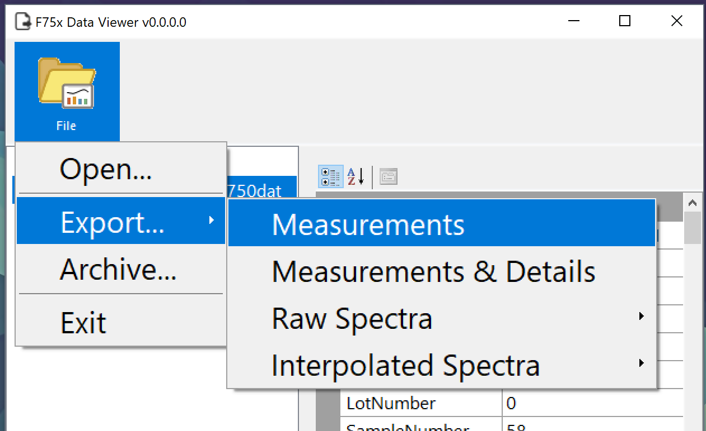
10. Select Measurements.

This will export the data to a CSV file that can be opened with Excel or another similar application…
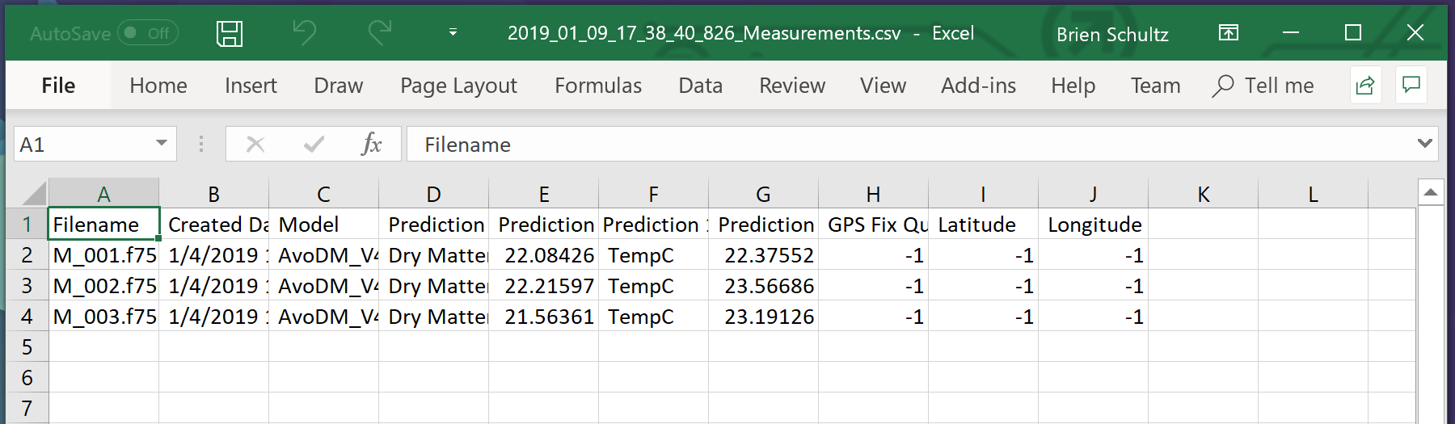

Downloading Measurements Using Wi-Fi

1. Power on your F-751.
2. Open the Wi-Fi settings on your PC and connect to the instrument’s wi-fi network.
Note: the device’s network will be F751_SerialNumber. For example, F751_14023.
3. Enter 123456789 for the password.
5. Open File Explorer.
6. Type \\192.168.0.1\DavWWWRoot in the address bar.

Troubleshooting

If something goes wrong the device can always be reset by pressing and holding the Power On/Off button for 20 seconds, waiting for two seconds, then pressing the Power On/Off button again.

Troubleshooting (Continued…)


Visit the Felix Instruments website for advanced troubleshooting, frequently asked questions, or to report a problem.
www.felixinstruments.com

Technical Support

If you have questions, online support is available at the following address…
http://www.felixinstruments.com/support
Felix Instruments is committed to provide customers with high quality, timely technical support.
Felix Instruments’ contact information:
Mailing Address  Felix Instruments  1554 NE 3rd Ave  Camas, WA 98607  USA | Phone  800-767-0119 (U.S. and Canada)  360-833-8835 (Other countries)  Fax:  360-833-1914

F-751 Production Test Check Sheet

Date: ________________________
Technician Initials: ________________________
Serial #: ________________________
Spectrometer #: ________________________
Firmware Version: ________________________

Spectrometer Pixel Coefficients
C0:
C1:
C2:
C3:
C4:
C5:
Spectrometer DAC Offset:
Reference Voltage:

Specific technology in this device was developed with the generous help and technical guidance of PROCINORTE, a network of national agricultural research bodies in the three countries of North America: Canada, USA and Mexico https://www.procinorte.net/.
Technology was also developed and licensed from Central Queensland University, Rockhampton, Australia https://www.cqu.edu.au/

